Sensor Biasing

Introduction
This article is about an improved sensor biasing circuit:

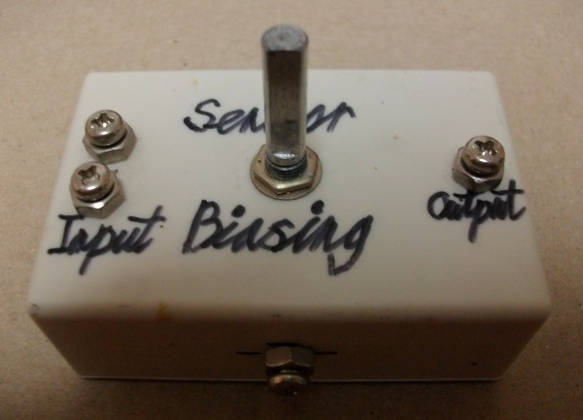
Figure 1: Sensor Biasing Device

This link shows you a simple sensor biasing circuit:

https://instructables.com/id/Simple-Light-Sensor

We all know that if you increase the resistance of the biasing resistor then you will also increase the circuit gain, making the circuit more sensitive. However, there are two problems with such modification:
1. The sensor can saturate and the circuit will provide you with almost zero output voltage.
2. You are reducing the sensor biasing current and some sensors have low gain at low biasing currents.

What I have done is constructed a circuit with maximum biasing resistance of 1 Megohm and a transistor current mirror source to pull the sensor output voltage to half supply voltage so that it does not saturate.

You can see my circuit working in those videos:

https://www.youtube.com/watch?v=7u_8HC6nLC4

https://www.youtube.com/watch?v=kqH5lz1Tvxc

Step 1: Design the Circuit
I drawn the circuit in the old PSpice software to reduce circuit drawing and simulation time:
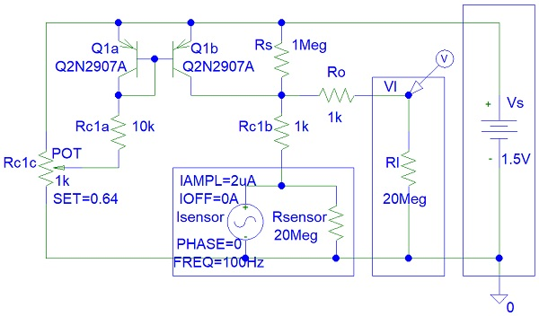
Figure 2: Design the Circuit

A similar circuit was published on: https://diyelectronics.narod.ru

You can google current mirror sources on the internet or click on this link to find out more:

https://www.electronics-notes.com/articles/analogue_circuits/transistor/current-mirror-circuit.php

Rc1a, Rc1b and Ro resistors are used for short circuit protection to avoid damage to the sensor and transistors. Those resistors are very important. You cannot just ground the PNP transistor collector pins. The transistors will fail very quickly.

I can ground the Rc1a resistor and increase its value to 1 Megohms or 10 Megohms. However, this would not give me an almost zero biasing current output for the current mirror source circuit. This is why I used a Rc1c potentiometer instead of grounding the Rc1a resistor. Otherwise I would simply replace Rc1a with a 1 Megohm or 2 Megohm variable resistor.

Rs is an optional resistor and can be removed. It is used to limit the circuit gain to avoid saturation due insufficient biasing current.

Step 2: Simulations

The simulations show that the output voltage drops to -0.5 V when transistor current is zero. If I make a real circuit, the sensor will saturate to about 0 V and the voltage will never fall below 0 V. Thus the simulations are not 100 % accurate because I could not find an appropriate model for the sensor in the PSpice simulation software student edition.

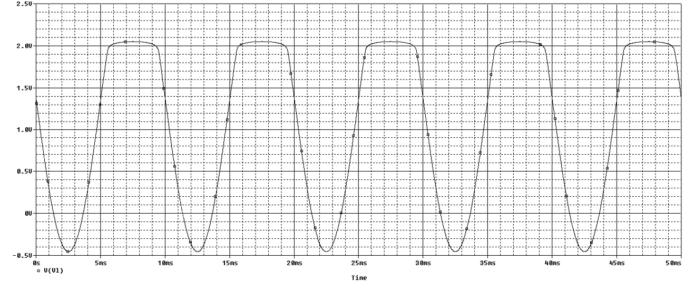
Figure 3: Simulations Rc1c set to minimum and transistors are OFF

You can see from the second plot that by changing the Rc1c value I have increased the biasing current and thus pulled the minimum output voltage to above 0 V and thus avoided sensor saturation.

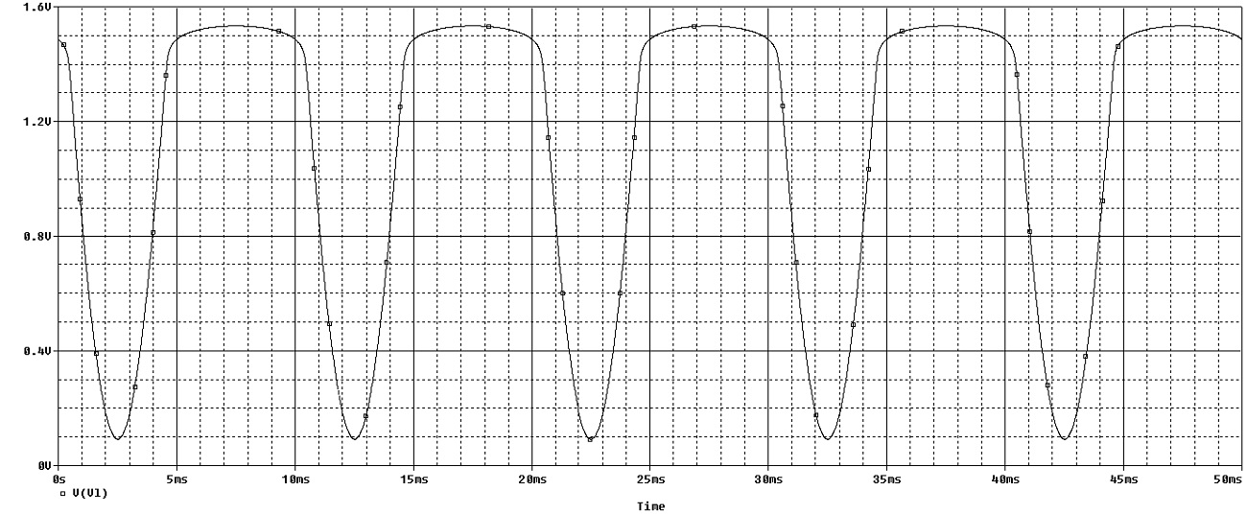
Figure 4: Simulations Rc1c = 0.64

Step 3: Make the Circuit
Any general purpose BJT PNP transistors would work with this circuit. You can see that I used three 680 kohm resistor because I did not have 1 Megohm resistor.

The wires are:
1. Red wire - Power Supply and Potentiometer.
2. Black wire - Ground, 0 V.
3. Two white wire pairs - To potentiometer.
4. Two yellow wire pairs - To sensor.
5. Single white wire - Circuit output.

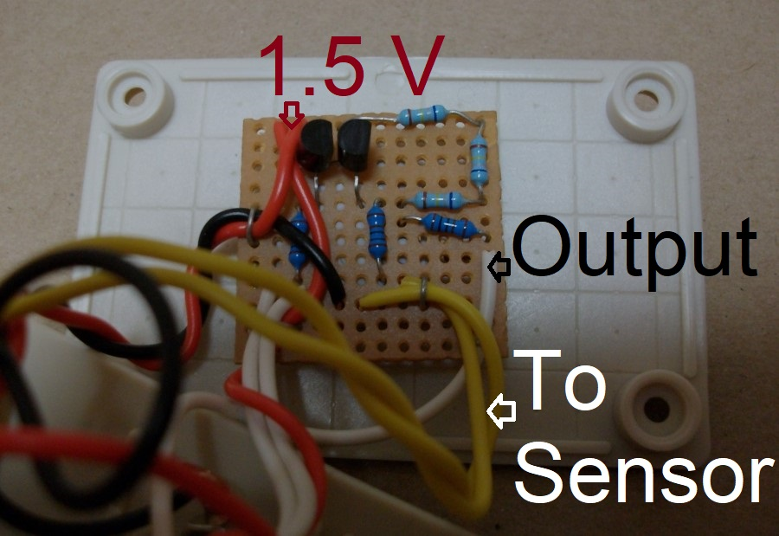
Figure 5: Make the Circuit

